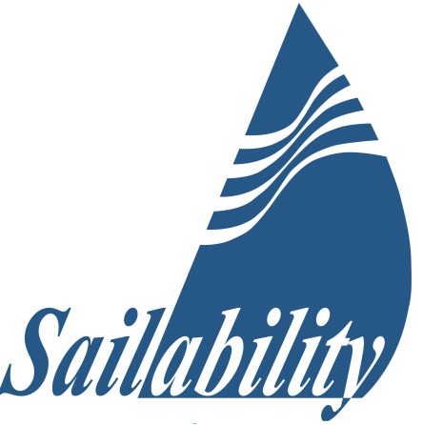 |  | Member  Application Form
(Club)  Sailability (Club) is an incorporated association (Queensland) and affiliated with Sailability Queensland.  As a member you will be respected and your contribution will be valued.  Some roles at (Club) involve risks. We have procedures in place to mitigate these. For your safety, the safety of other members and our clients, you will be expected to follow relevant procedures and any reasonable requests from appointed officers.  This application asks you for some personal information. It will be treated in confidence except to the extent that it may be needed in case of an emergency or in relation to training activities.  As we work with children from time to time you will be required to have or to be eligible to obtain a positive blue card. This may involve police checks.  Membership is (Free/Fee)  Contact  (Your email address or other details)  Write to us  (Your postal Address or email) |  | NAME:  Address:  Home Phone / Mobile:  EMAIL:  Skills and memberships (please circle):  First Aid / CPR / Nursing / Sailing / Recreational Boat Licence  Marine Radio Licence / Blue Card  Other interests and hobbies (please advise):  Business -  Volunteering and other -  Do you have a medical condition we should know about?  Condition(s) –  Emergency Contact (relationship, name & phone):  Your signature: Date:

